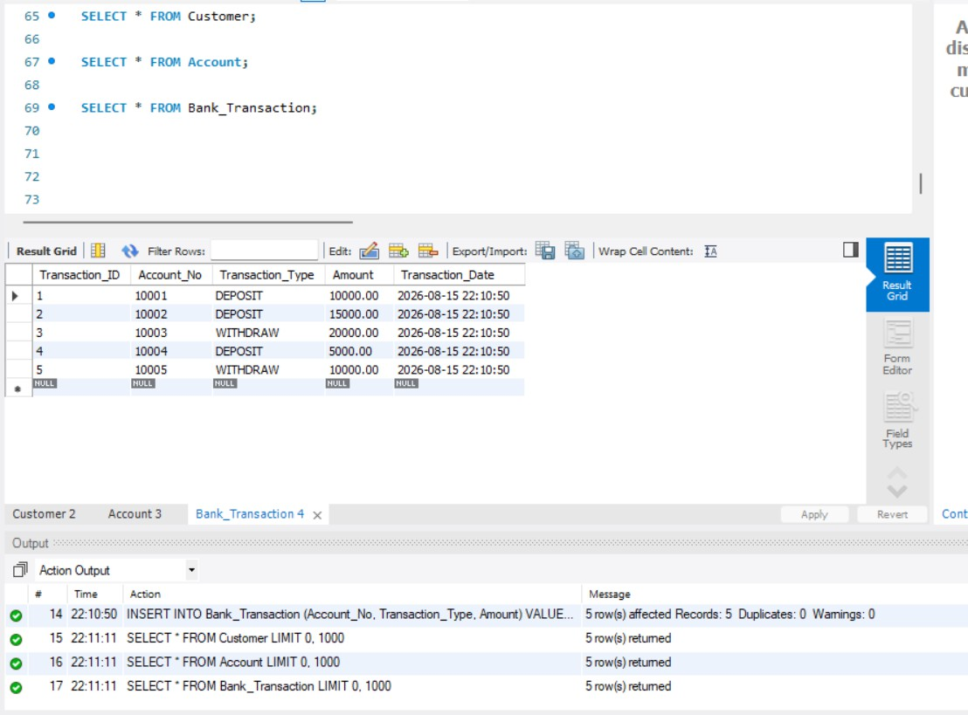
- DISPLAY DATA

- DEPOSIT MONEY
CH.MADHULIKA_2520090056 SKILL-WEEK-3

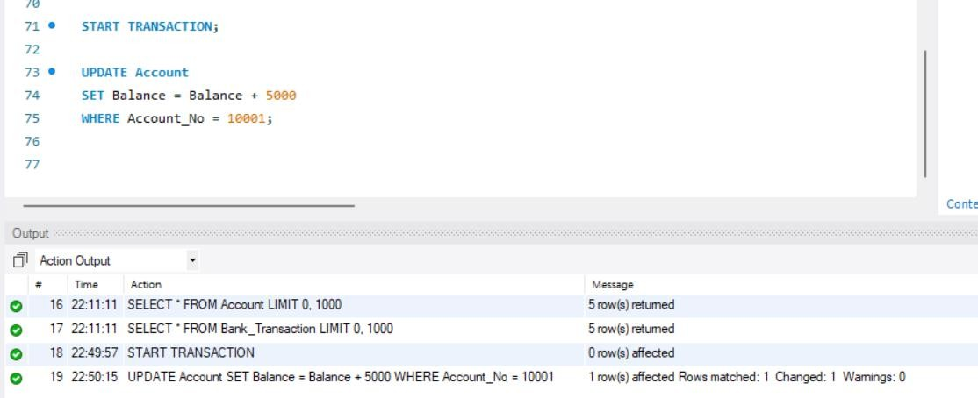

- CHECK BALANCE
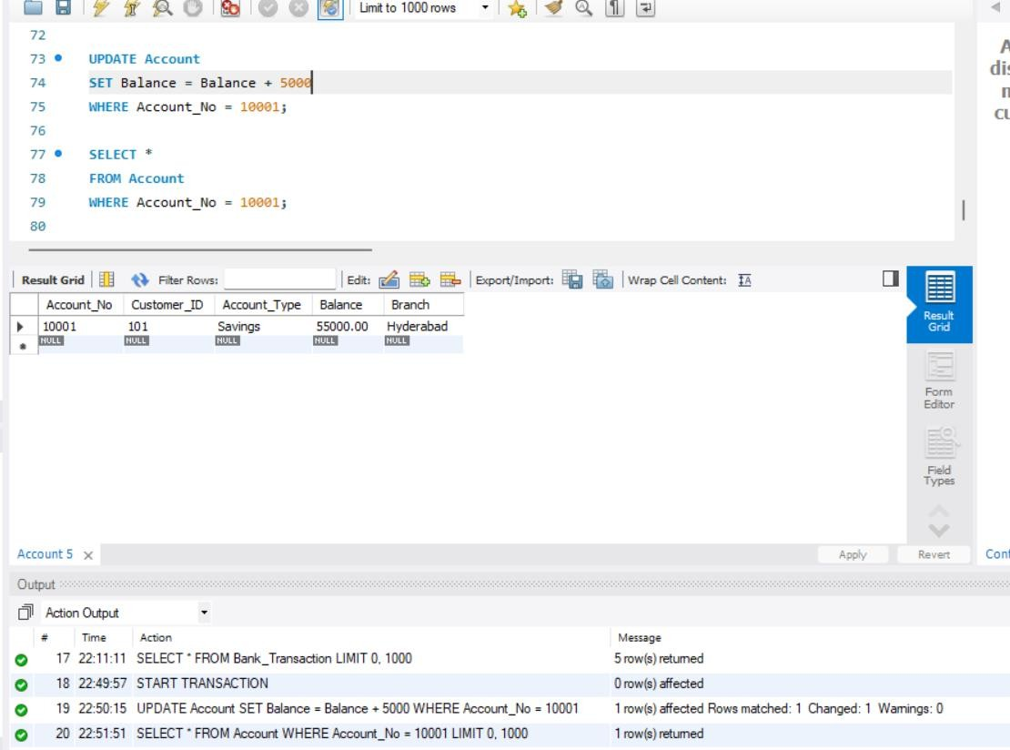
- CHECK BALANCE AFTER COMMIT
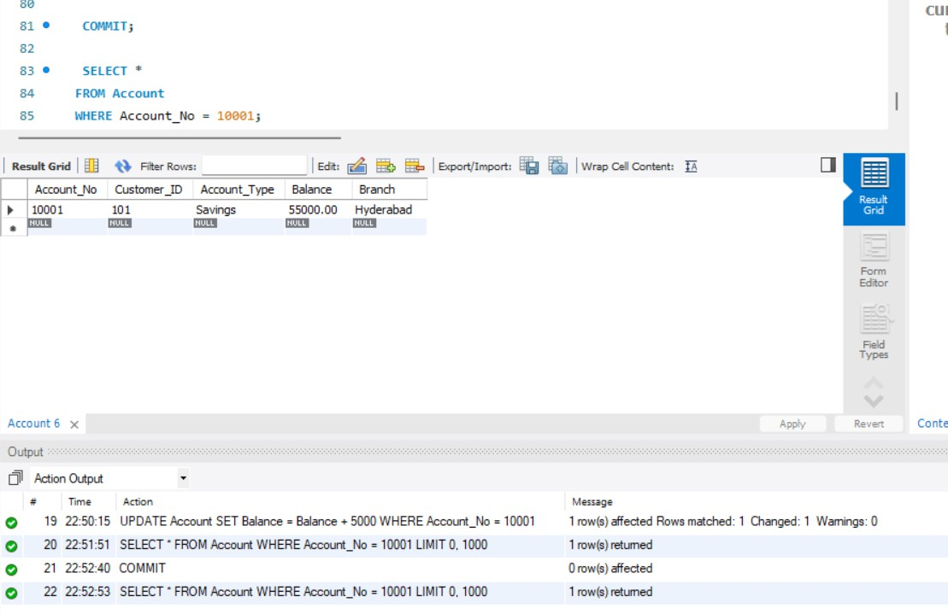

ROLL BACK
4. WITHDRAW MONEY

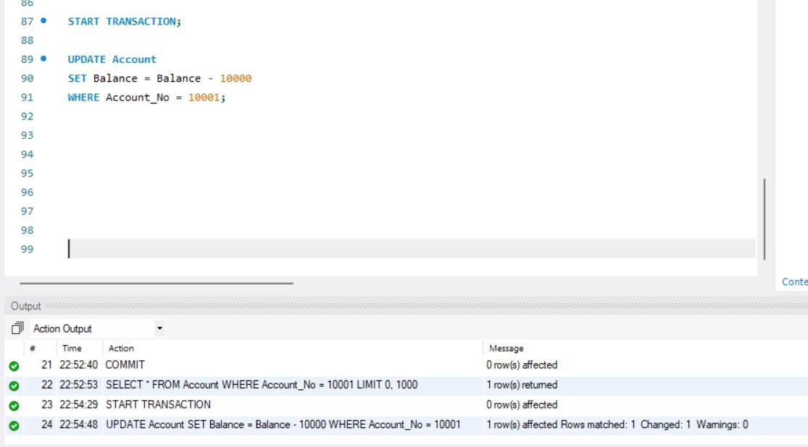
- CHECK BALANCE
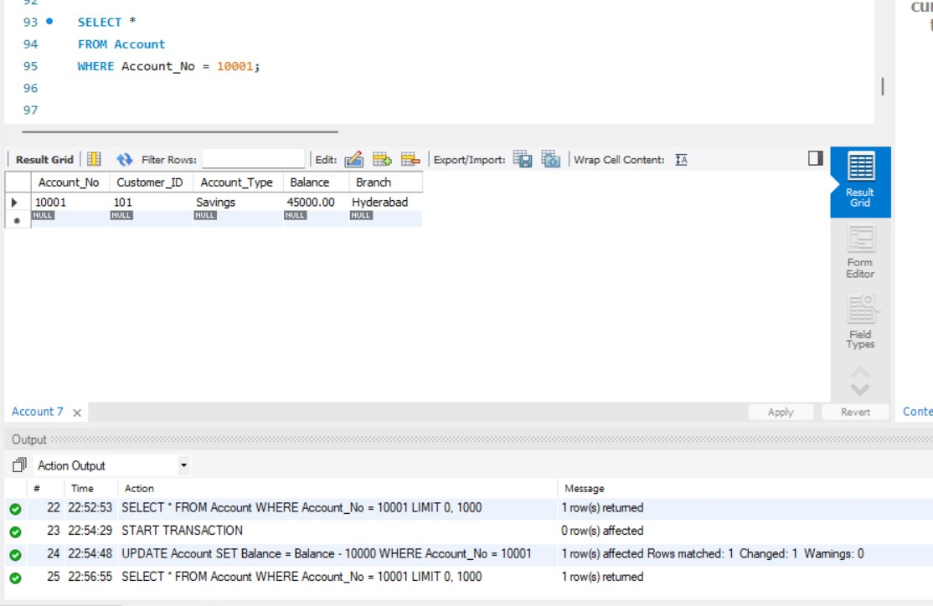

- CHECK BALANCE AFTER ROLLBACK
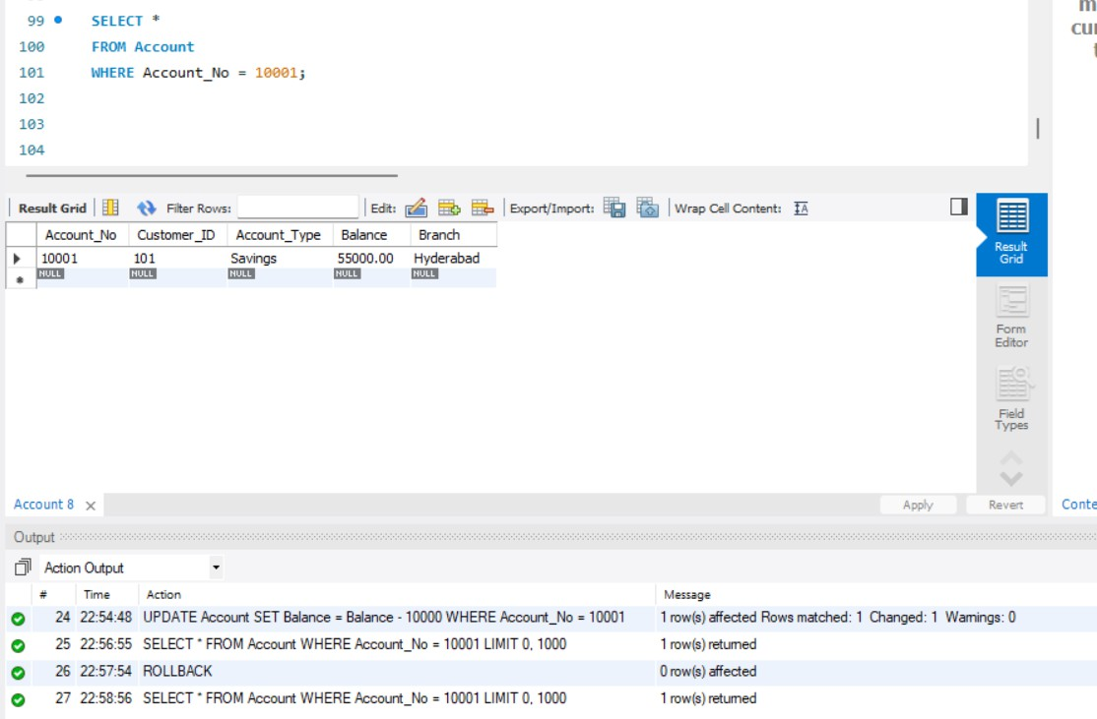
SAVE POINT
- FIRST UPDATE
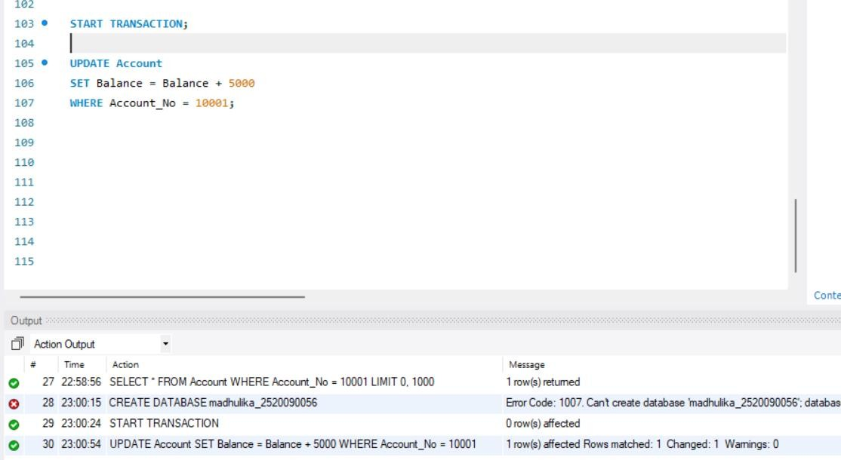

- SECOND UPDATE
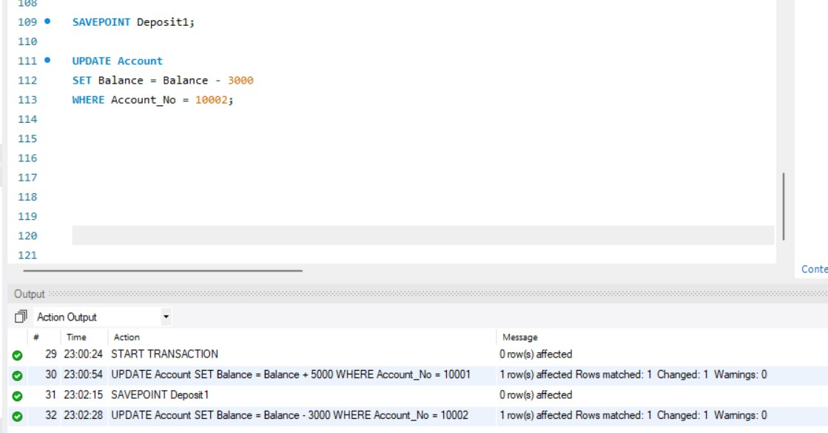
- THIRD UPDATE
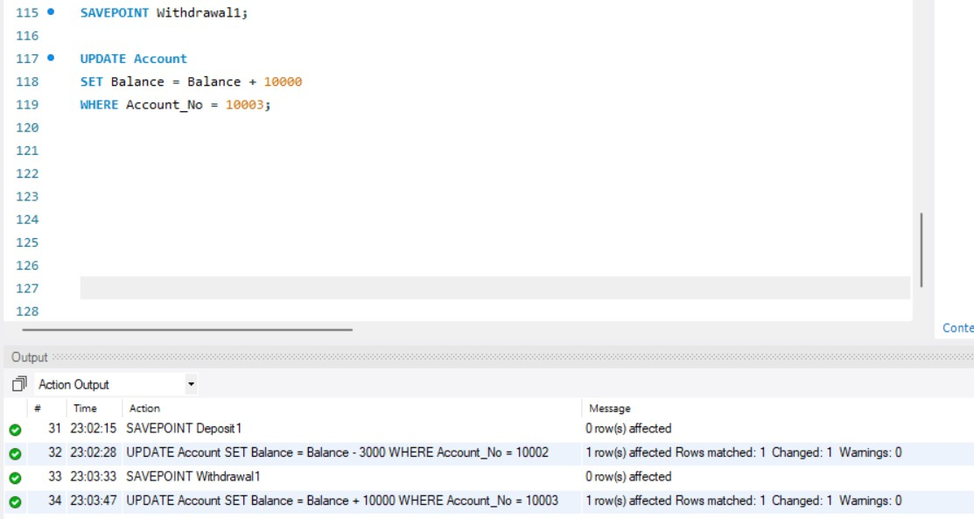

- CHECK ACCOUNTS
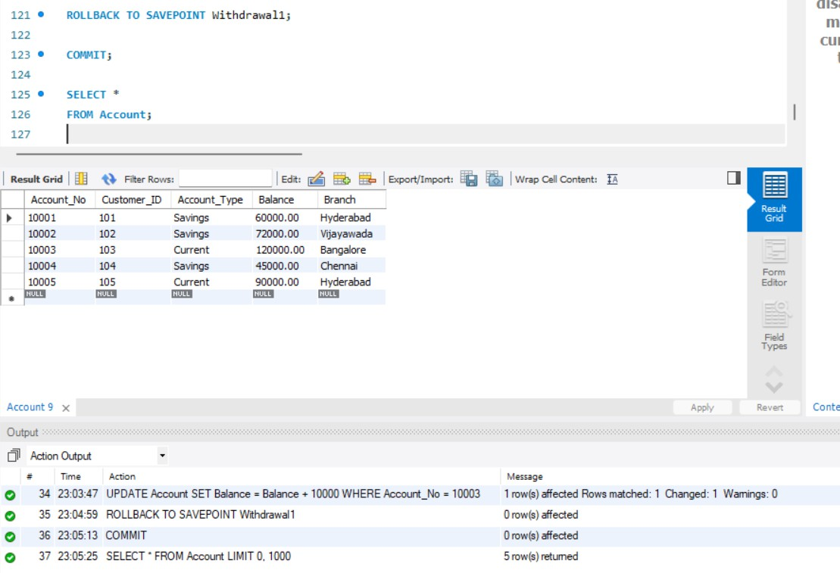
BANK TRANSFER
- DEDUCT FROM SENDER
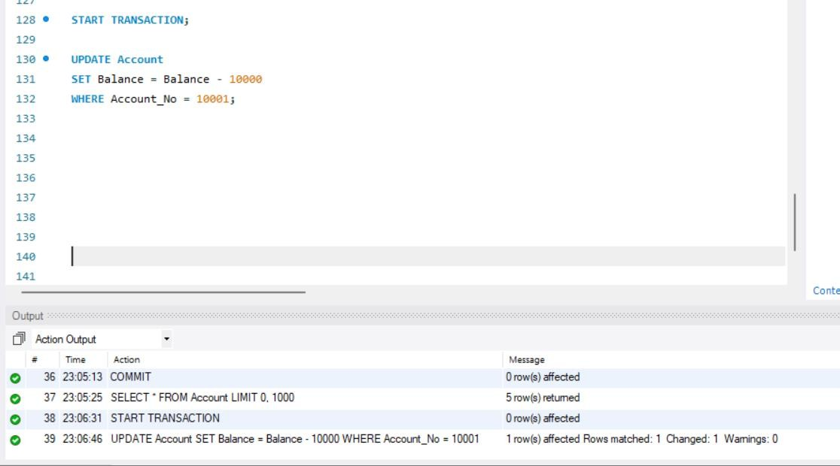

- ADD TO RECEIVER

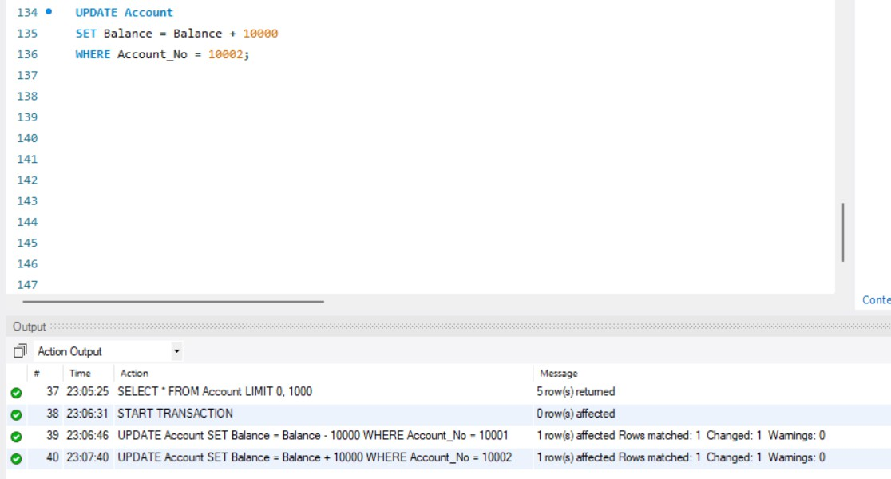
- CHECK BOTH ACCOUNTS
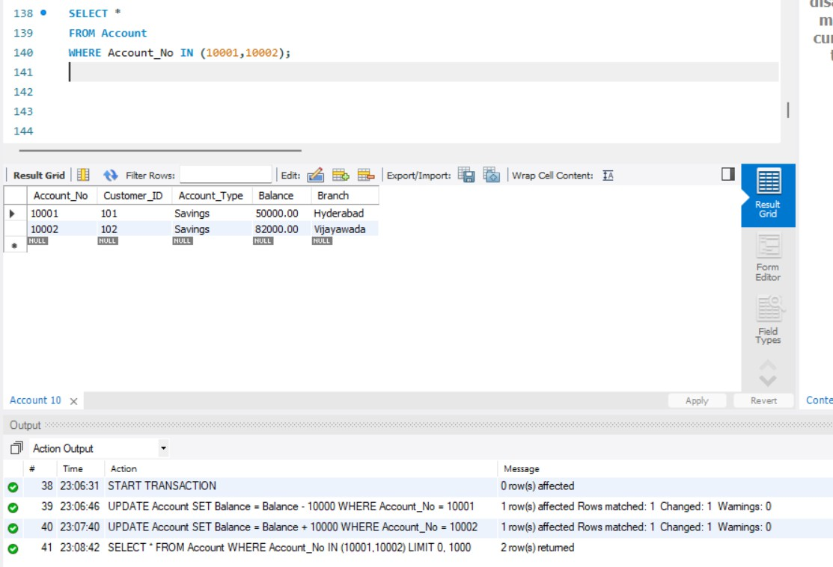

- FINAL BALANCES
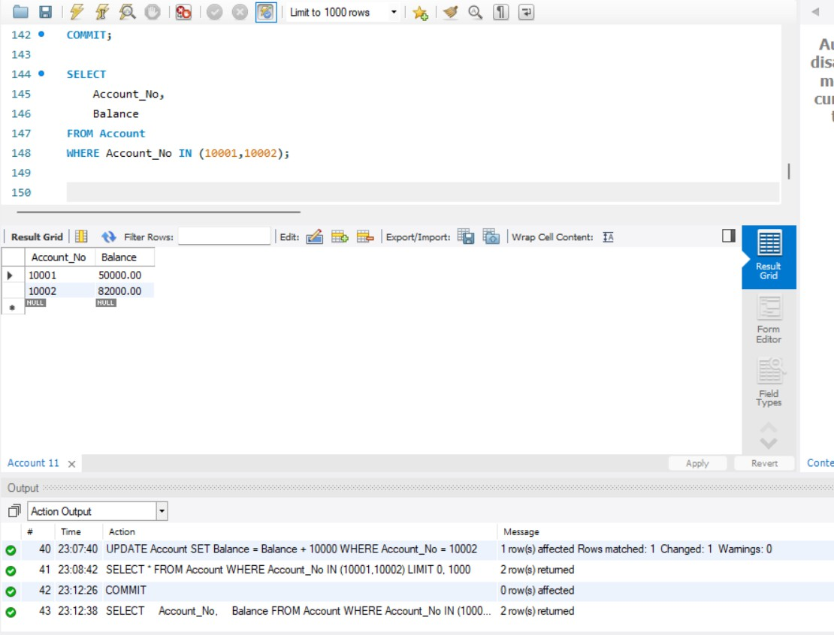
TRANSFER USING ROLLBACK
- DEDUCT MONEY
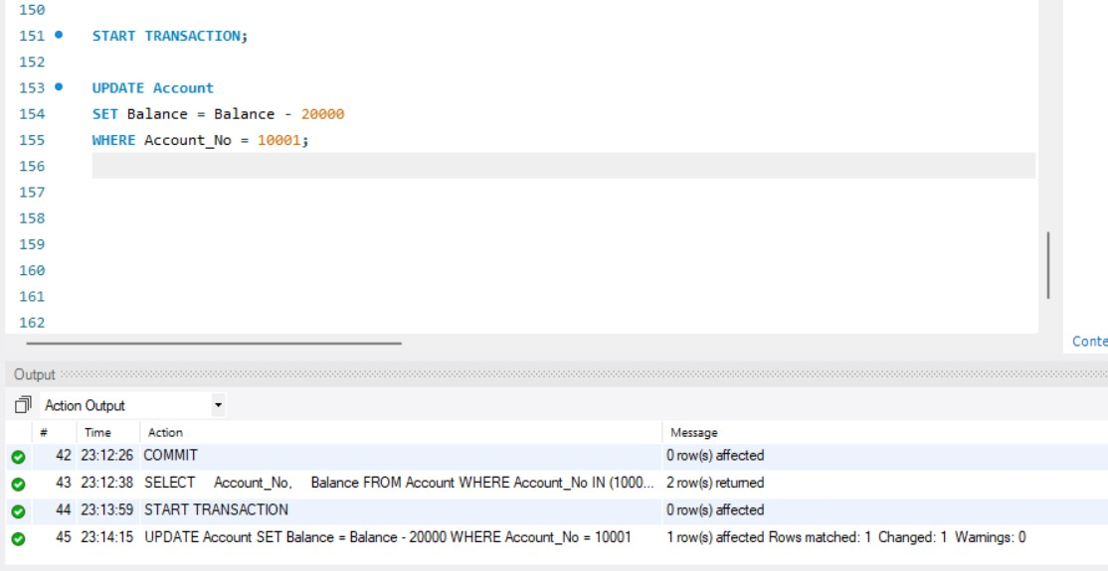

- ADD MONEY
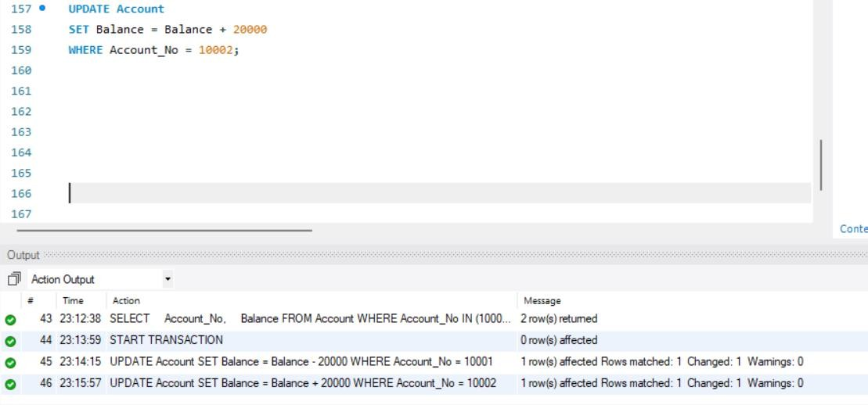
- CHECK BALANCE
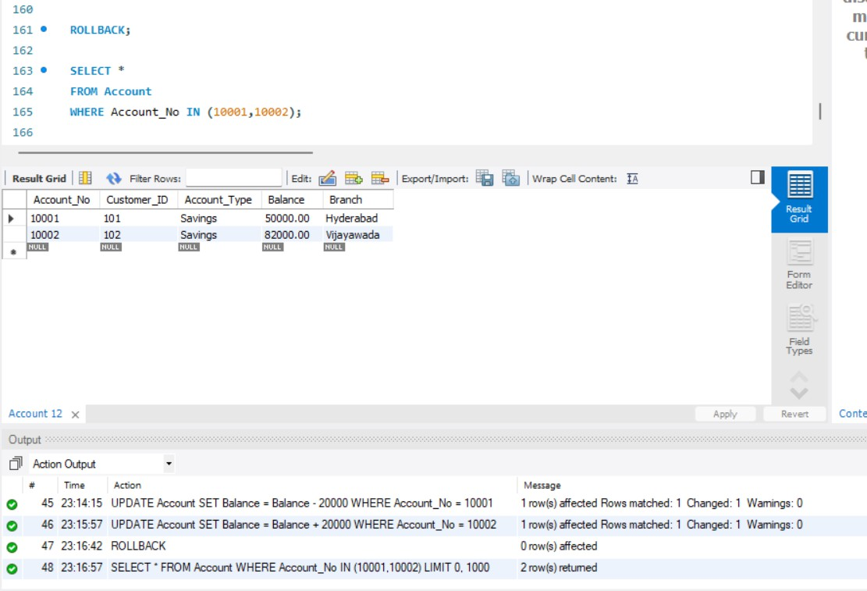

ACID
- ATOMICITY
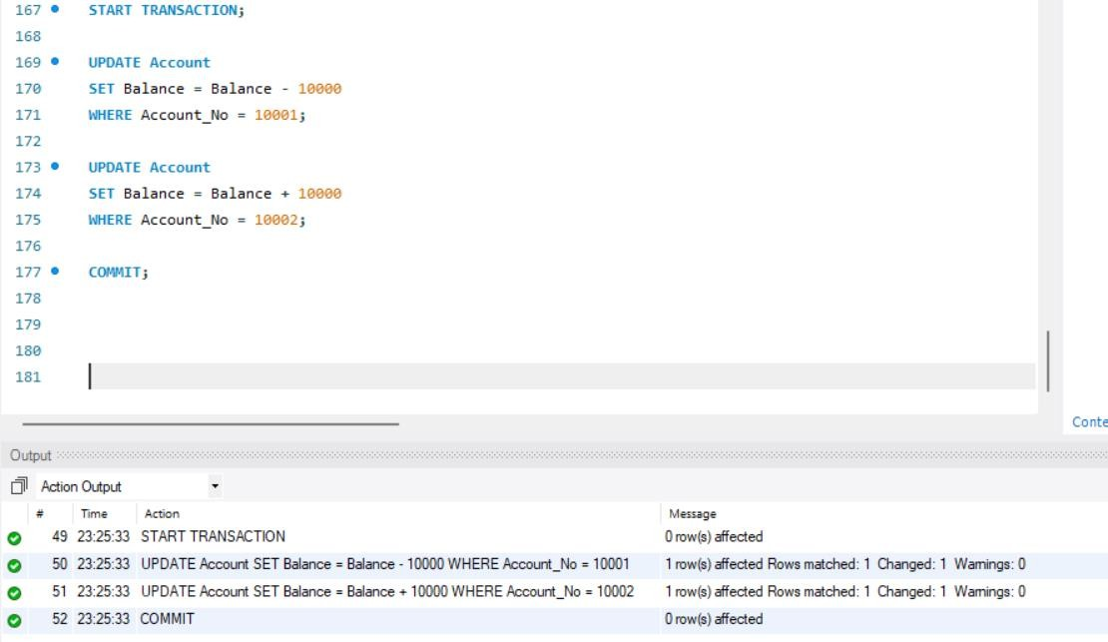
- DURABILITY
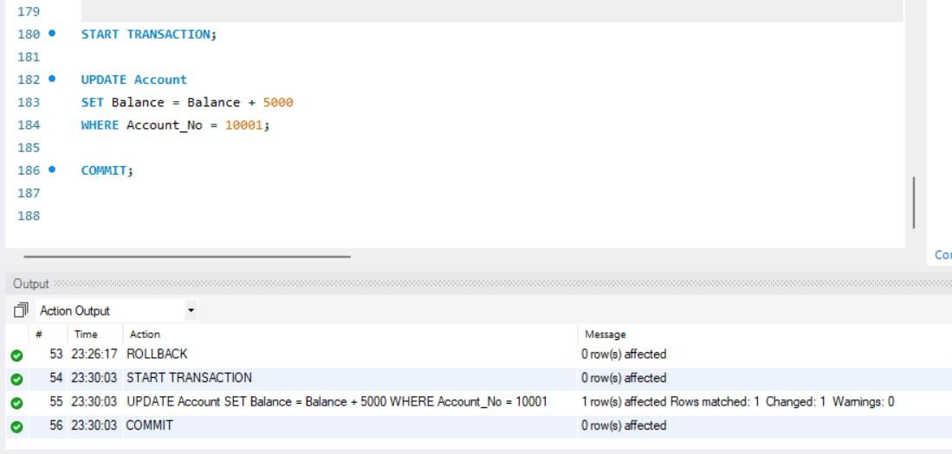

TRANSACTION ISOLATION LEVELS
- CHECK CURRENT ISOLATION LEVEL
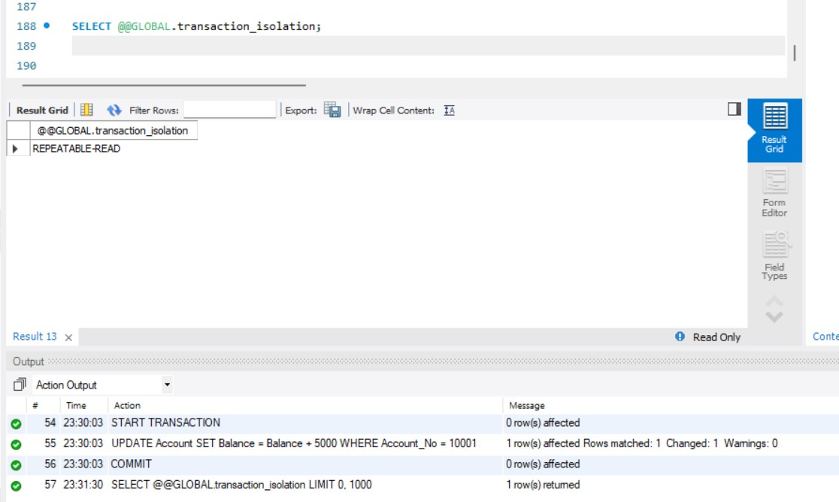
- READ UNCOMMITED
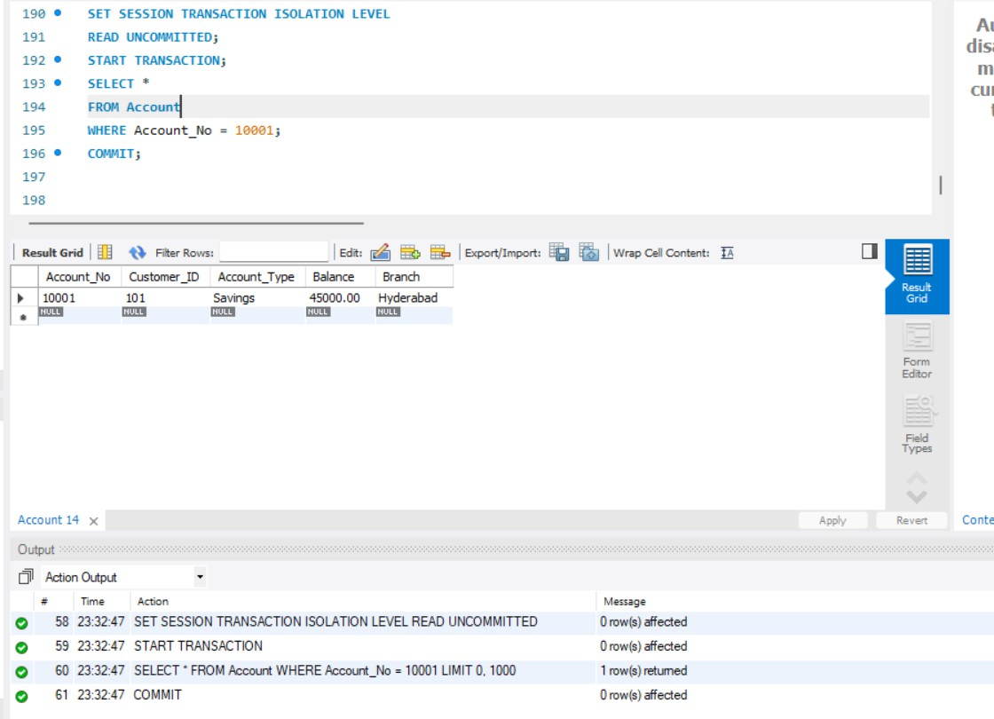

- READ COMMITED
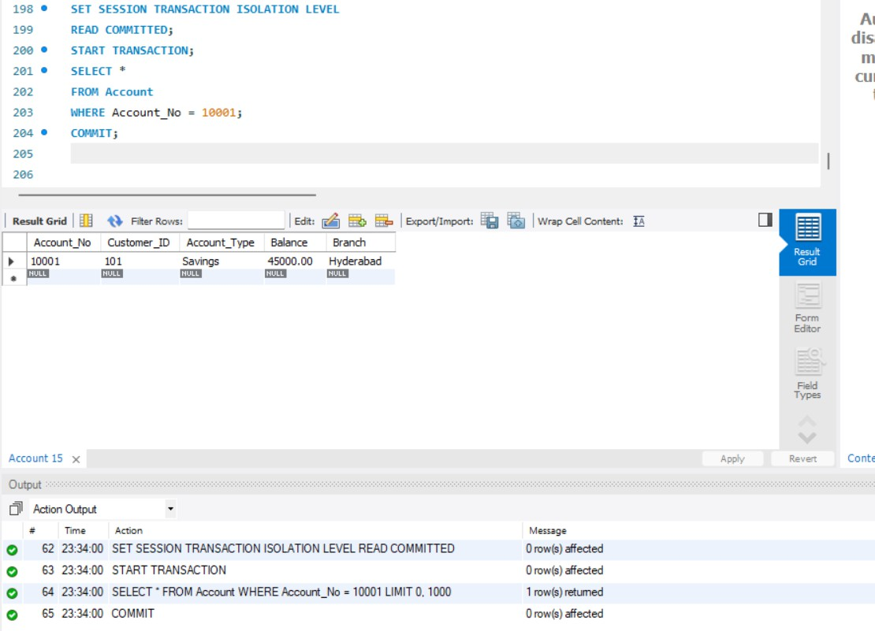
- REPEATABLE READ
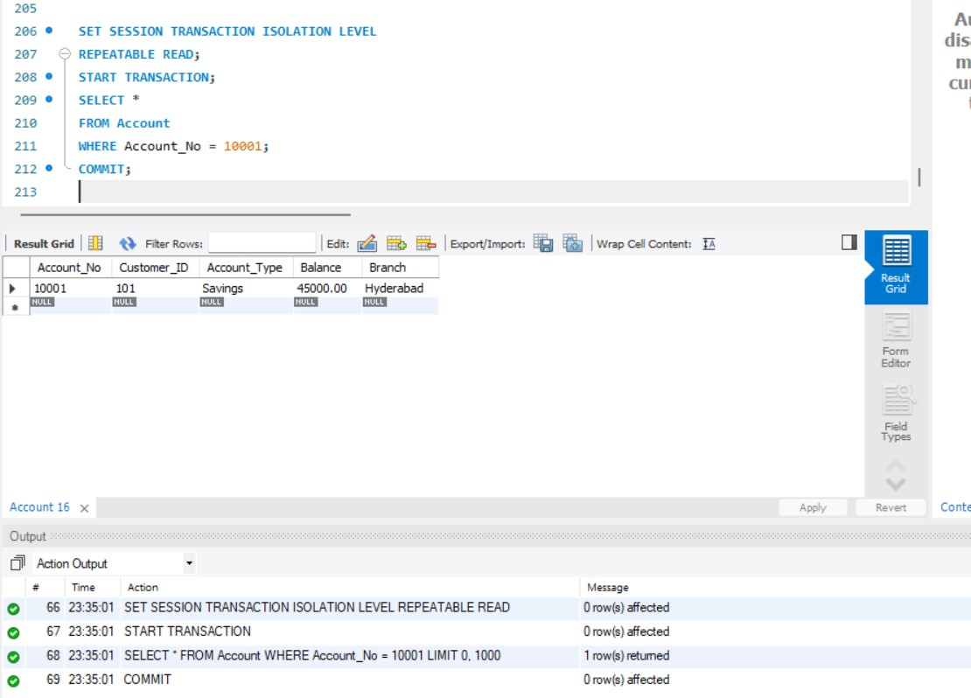

- SERIALIZABLE

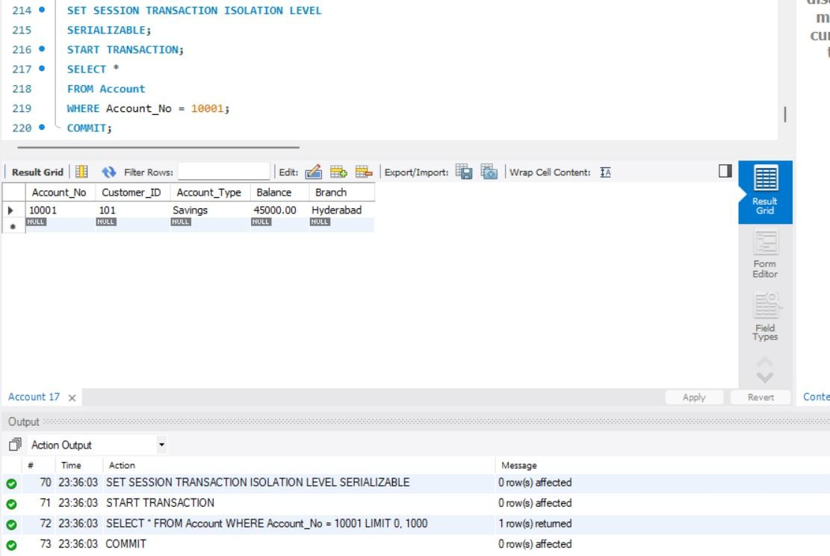
- DIRTY READ EXPERIMENT
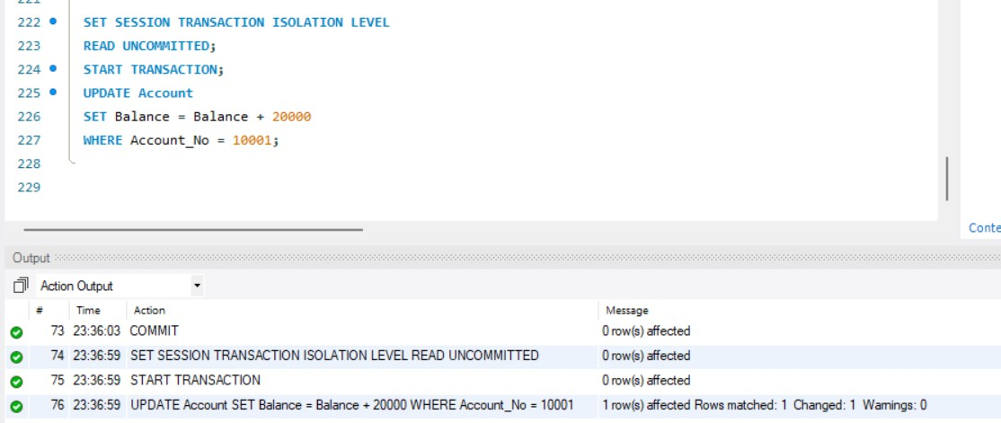

- SESSION -2
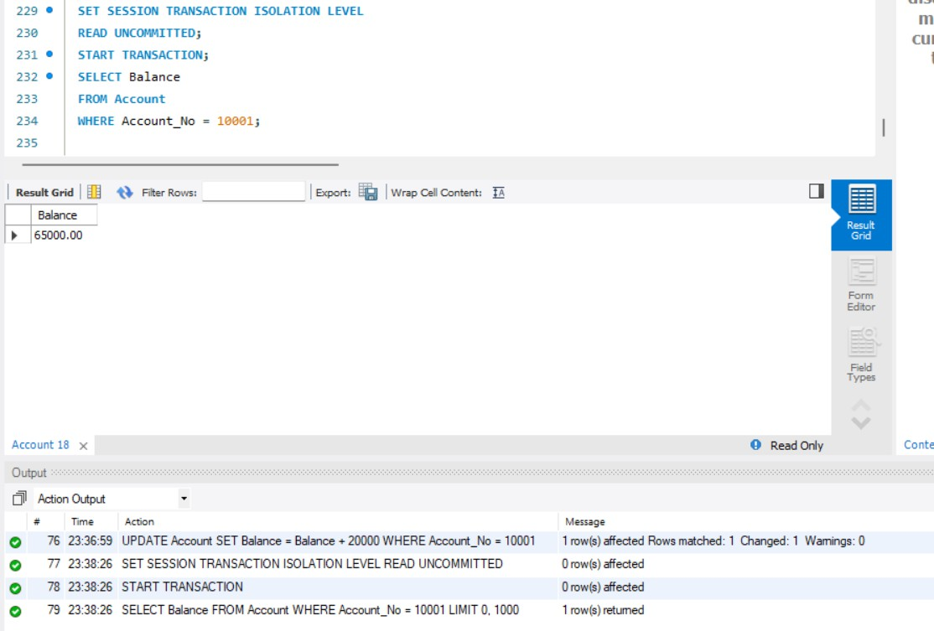
READ COMMITTED EXPERIMENT
- SESSION-1
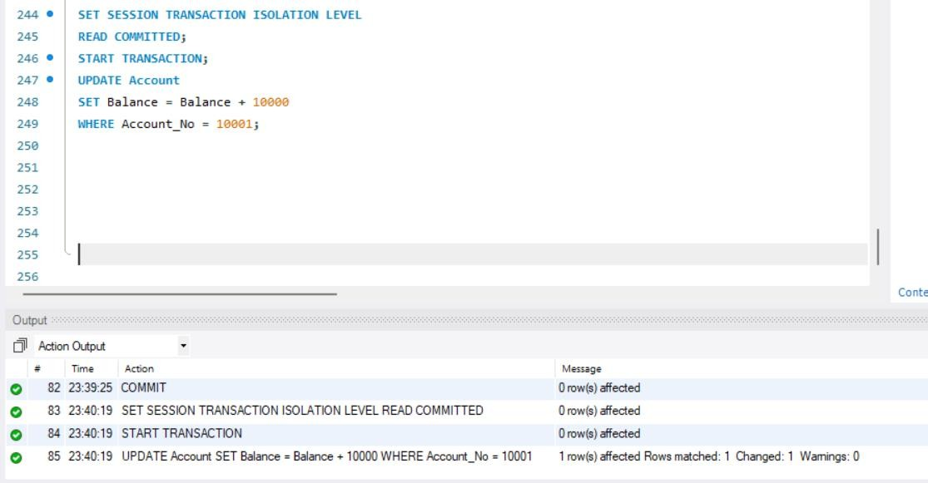

- SESSION-2
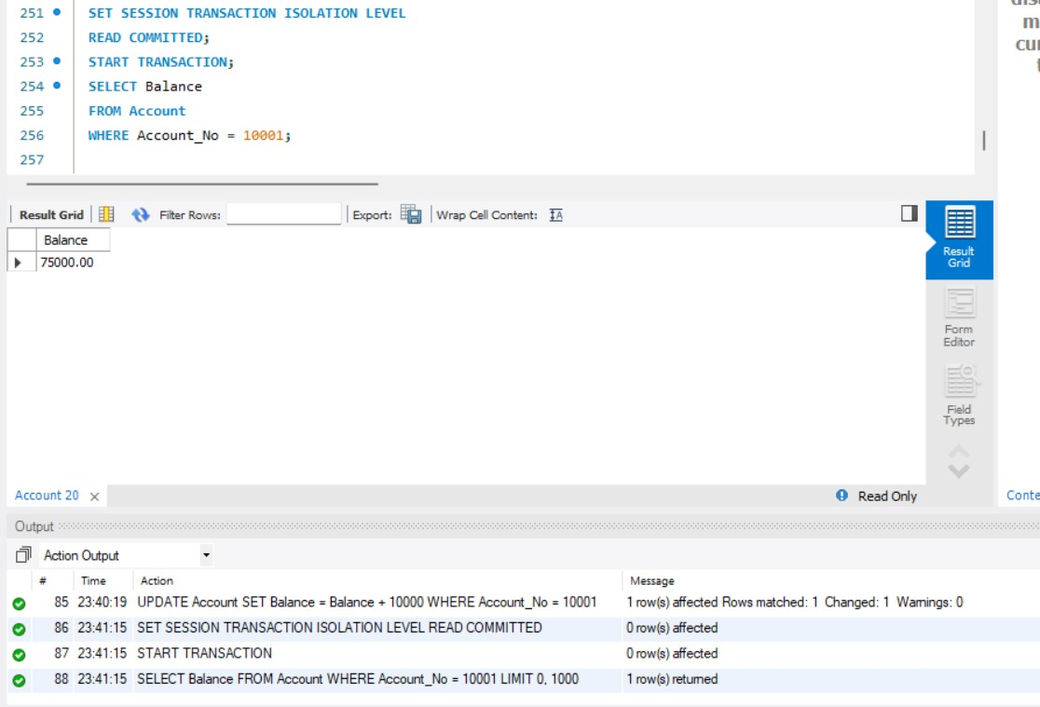
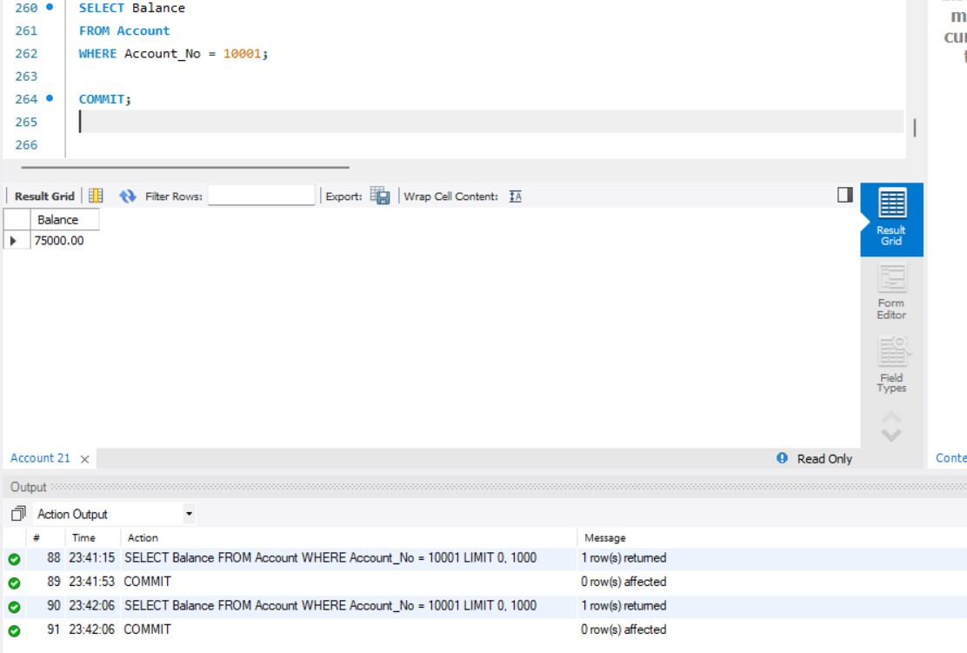

REPEATABLE READ EXPERIMENT
- SESSION-1
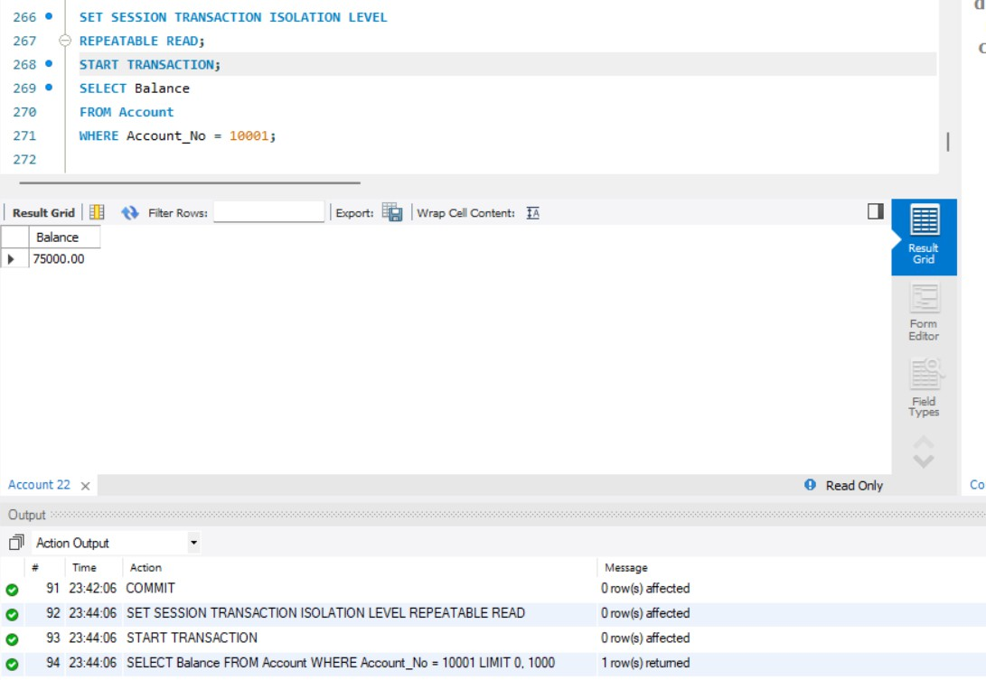
- SESSION-2
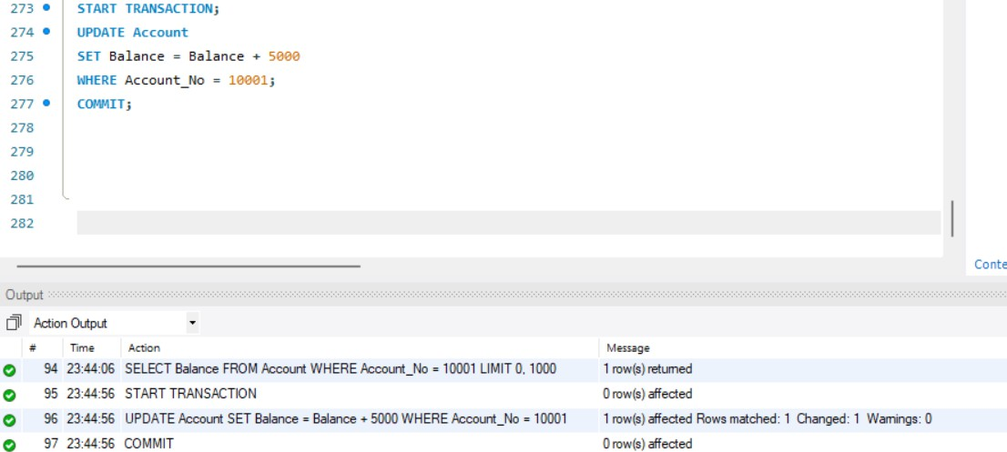

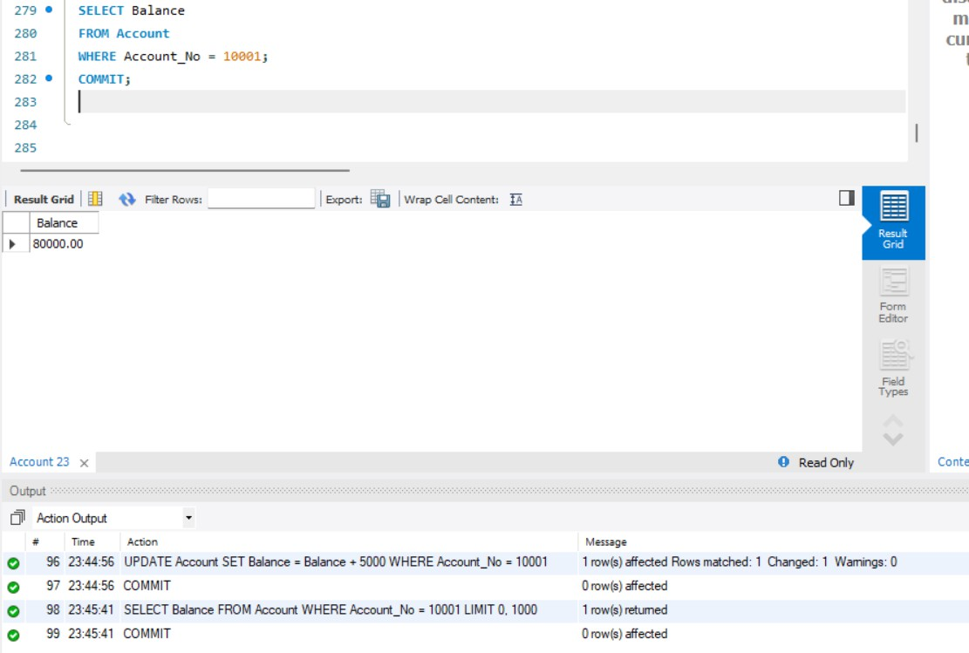
SERIALIZABLE EXPERIMENT
- SESSION-1
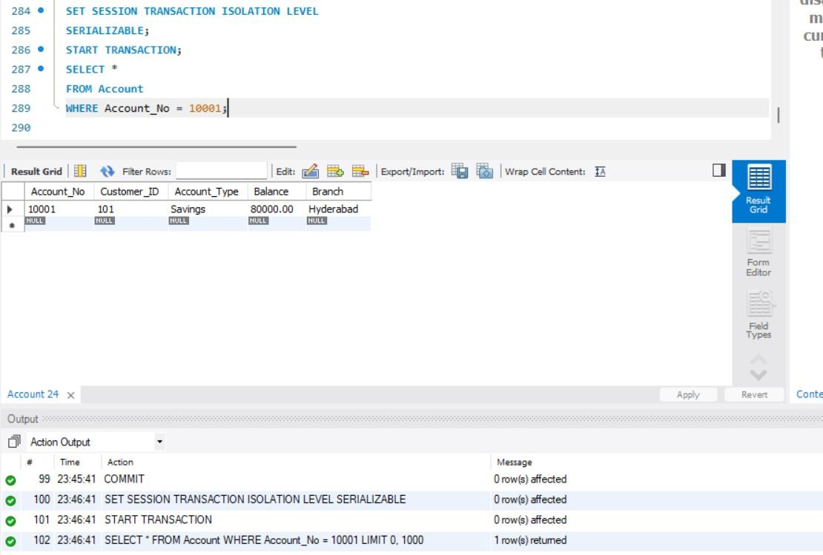

- SESSION-2
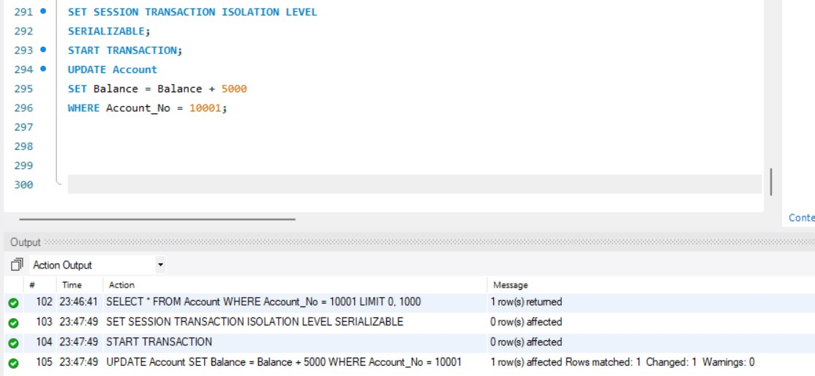
- TRANSACTION COMMANDS
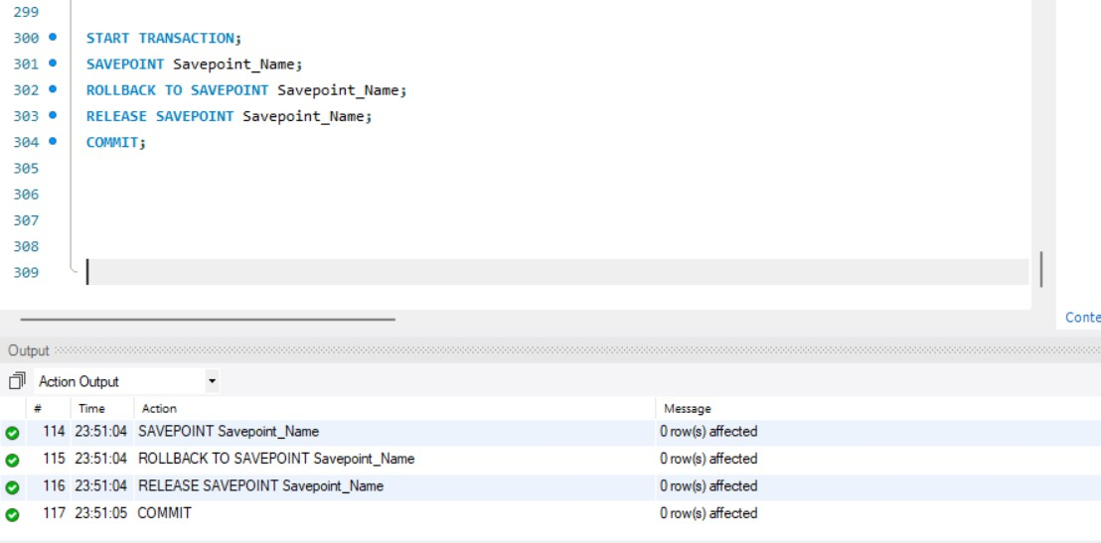

BANK TRANSACTION EXAMPLES
- DEPOSIT TRANSACTION

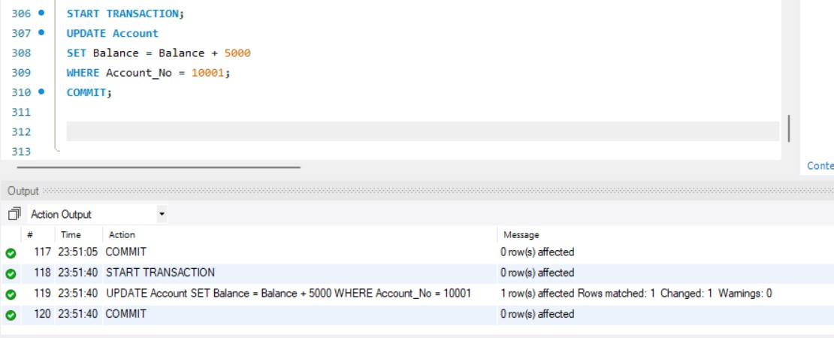
- WITHDRAWAL TRANSACTION
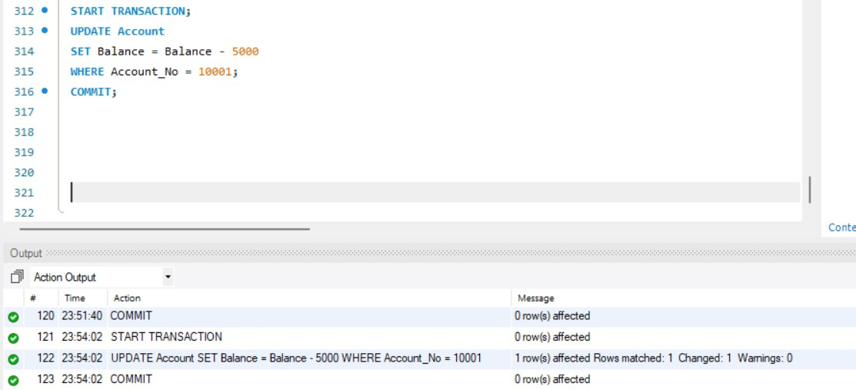

- CANCEL WITHDRAWAL

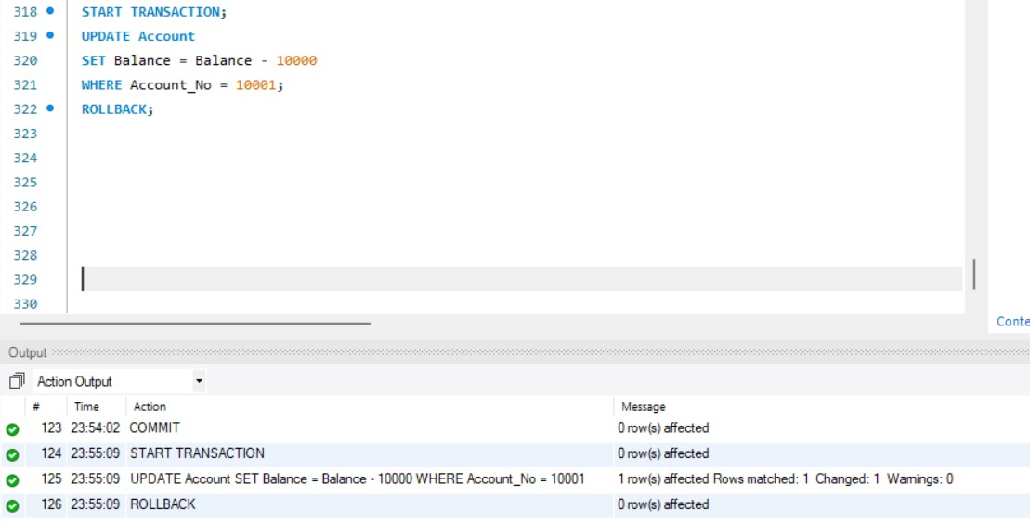
- TRANSFER WITH SAVEPOINT
